What are the data you need from DepEd DDO?
- List of Districts
- List of Schools

Task 1: Job Vacancy Posting (hris_jobvacancy)
Already posted, ayaw na e touch kai naa pai error.
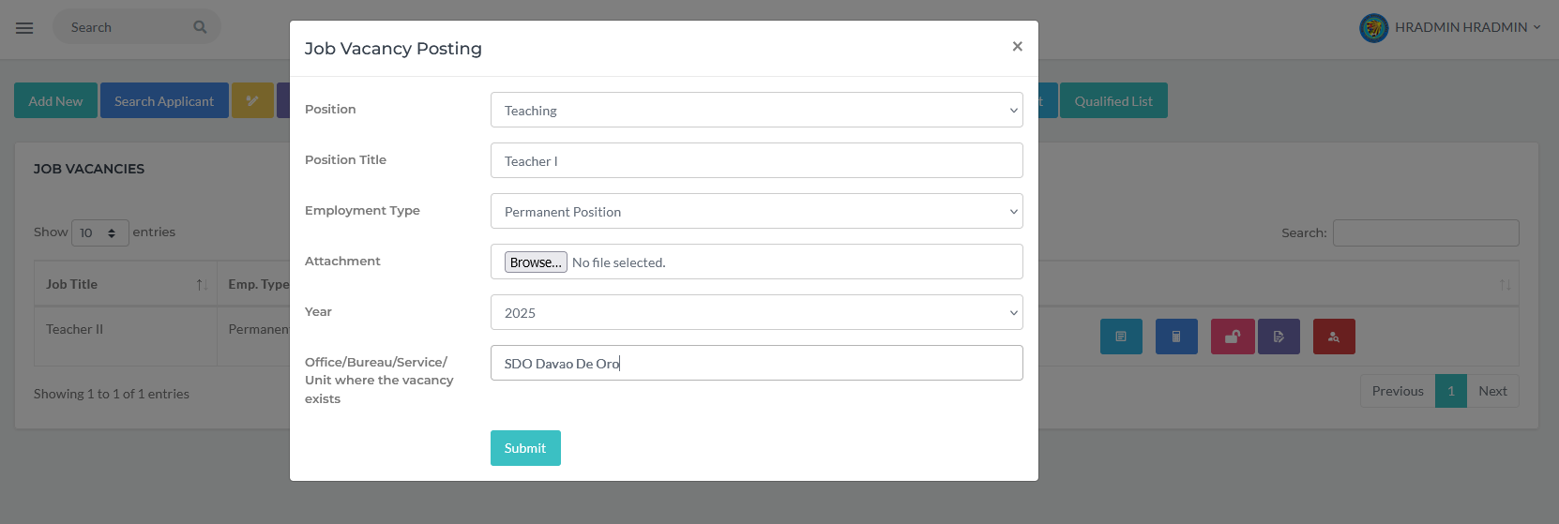
Note: Make sure that the attachment is in PDF format. Ang attachment could be a memo for that particular job vacancy.
Task 2: Applicant Registration (hris_applicant)
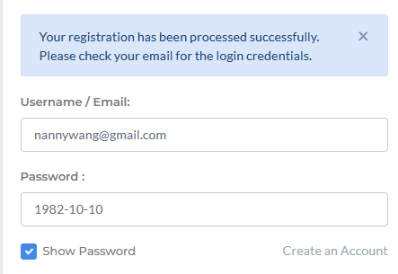
- By default, the username is the email address used by the applicant in creating their account. The password is their birthdate using the format YYYY-MM-DD
- The system will also send an email to the registered email address
- After creating their accounts, they are required to edit their profile.
How to Apply?
- From the Recruitment menu, click on the Job Vacancy
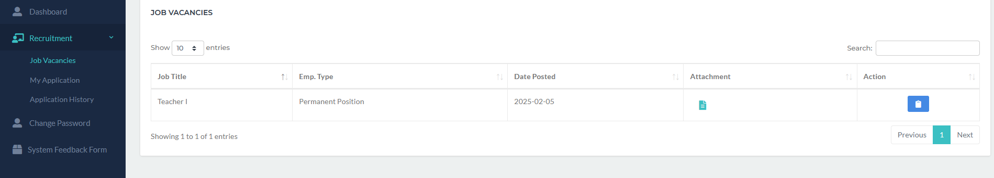
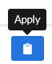
- From the Action column, click Apply .
- The following form will appear:
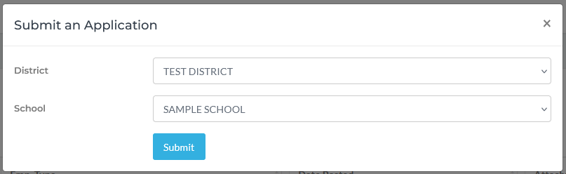
- Select your preferred District and School then click the Submit button.
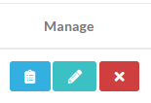
- From the Manage column of the application list, click the button.
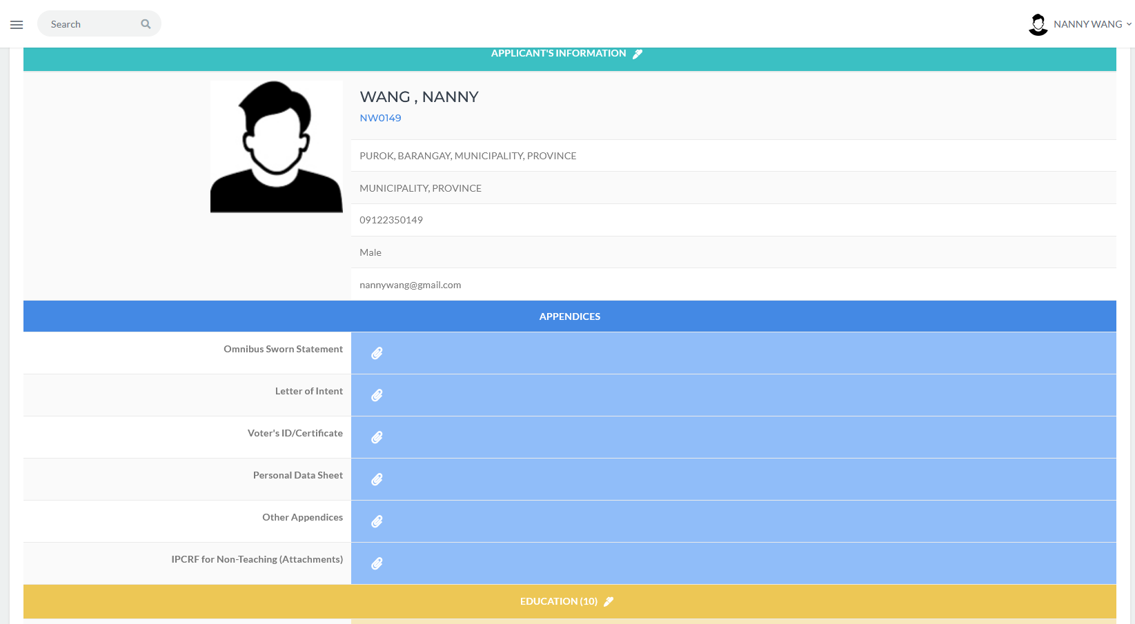
- The applicants may now be able to upload the attachment for item listed from Appendices down to LET rating.

